Ruiqi Mao

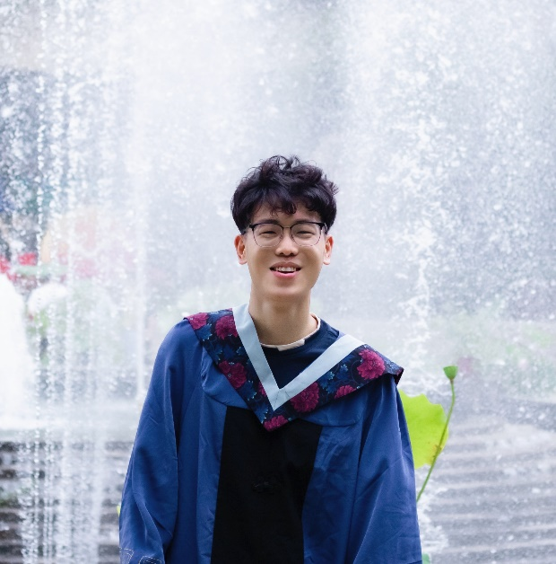

### ABOUT ME

I am a junior undergraduate student at Huazhong University of Science and Technology (HUST) in China. I am major in Mechanical Design manufacture and Automation. Currently (2022), I am working as a summer intern in University of Alberta under the China Scholarship Council (CSC) Funded Internship program.

**SUPERVISOR**

Dr. Hossein Rouhani

### RESEARCH INTERESTS

Mechanical Design

Robotics

Mechatronics

Embedded Systems

Control Systems

Automation

Human-robot Interactions

### ****PROJECTS****

**University of Alberta**

* **Augmented Cane**

It is a cane developed by the students in Stanford University which use multimodal sensing and intuitive steering assistance to improve navigation and mobility for people with impaired vision.

* **Prosthetic Hand**

The project proposal was to develop a prosthetic hand that would be accessible with an affordable implantation cost. Functional with an EMG-controlled system, and scalable to customize EMG processing to each user.

* **Motion Sensor Glove**

The glove attached to 16 IMUs can get the motion and position of the user’s hand.

* **Volunteering in some tests**

I participated in some other projects about EEG system and motion capture as a volunteer for tests.

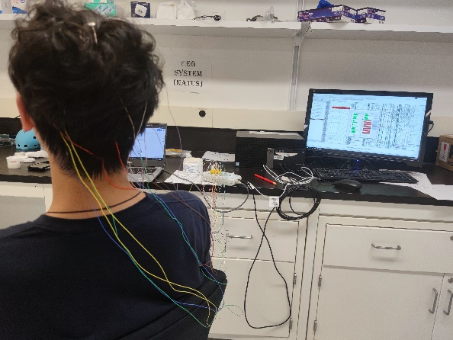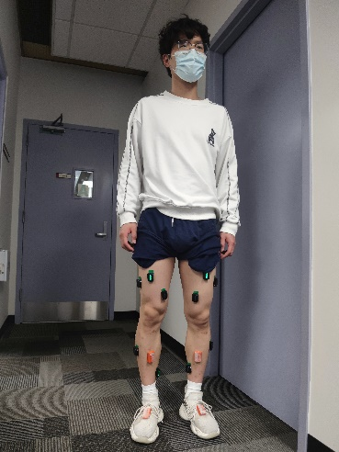

**Huazhong University of Science and Technology**

* **National College Mechanical Innovation Competition**

From May 2021 to June 2022, our group of five students designed and made a ship to clean the oil spilled at sea. We won the provincial first prize.

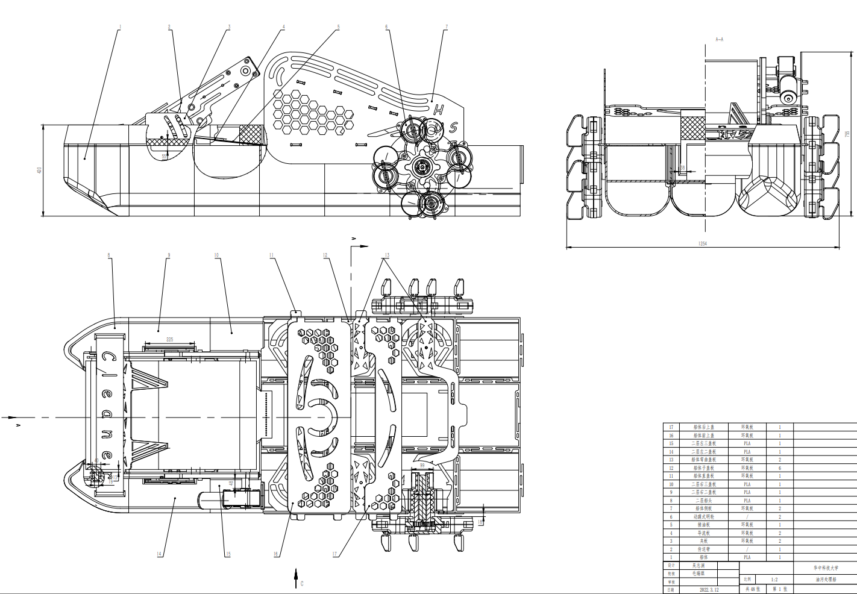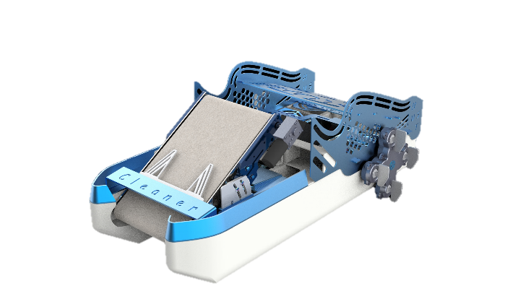

* **College Students' Innovative Entrepreneurial Training Plan Program**

From August 2021 to May 2022, our group developed a cylinder control board based on ITV2050-312L electric proportional valve.

* **China College Students' 'Internet+' Innovation and Entrepreneurship Competition**

From May 2022 to present, our group are working on developing an integrated mobile robot for carrying and operation.

**University of Cambridge**

* **Cambridge Online Research Program in Smart and Advanced Manufacturing**

From 10th February to 25th February 2022 by the Cambridge Centre for the Integration of Science, Technology and Culture of the University of Cambridge.

### AWARDS AND HONOURS

* First prize in the 20th National Robotics Competition for College Students (ROBOCON 2021)
* Provincial first prize of the National College Mechanical Innovation Competition (2022)
* Outstanding Report Winner in the Creative Thinking and Research Methods program, HUST (2020)
* Successful Participant in Mathematical Contest in Modeling (MCM 2022)